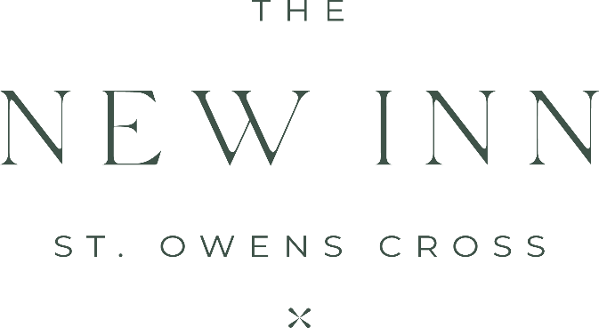

Tasting Menu
£65.00
Or £94.00 with Wine

Homemade Breads

Organic Salmon
Treacle Yogurt , hot smoked belly, citrus cured salmon, smoked cod’s roe and avocado ice cream
Paired with our Spanish Altozano Verdejo Sauvignon Blanc

Red Onion Tart
Simon Weaver Organic Cotswold Brie, pickled apple and apple marigold
Paired with our French Whispering Angel Rose

Aged Fillet of Beef
Potato and shallot pressing, spinach, Jerusalem artichoke and lobster ravioli
Paired with our Romanian Cramele Recas Pinot Noir

Hot Chocolate Mousse
Condensed Milk Sorbet

Blackberry soufflé
Blackberry ice cream and spiced blackberry syrup
Paired with our Sixteen Ridges The Blenheim Superb Iced cider

